From: Pam Wood
Sent: 07 September 2025 14:12
To: transport@greystokevillage.co.uk <transport@greystokevillage.co.uk>
Subject: Bus User Group - September update

Hello and welcome to your September update!

So, it's not great news I'm afraid, despite lots of positive stories and lovely messages of support, the data on volume of passengers is low and Mark Hodgkiss at Westmorland and Furness Council emailed me last month with a stark message: "...on current data I cannot see the contract being renewed when it comes to an end in March".

Tim Farron, MP, wrote to the council and Stagecoach after he took a bus ride with us and Stagecoach are still adamant that diverting the x4 / x5 is not an option they will consider. I then met with Mark H to look at our options; we looked at simplifying the timetable / route and reducing the number of journeys per day so it's less costly to run. Mark is now discussing those proposals with Stagecoach with a view to the changes coming into effect in November.

There were 5 bus cancellations during August, not ideal but also not surprising given the congestion around Penrith during the holidays, many more journeys were fine.

As you know, we have support from the council and from our Councillor and MP, but there's really only so much they can do. If you have any ideas for increasing use, please send em over; if you run a business and would like to offer a discount, please get in touch.

I'll be sure to update you, but please, if you want to keep the bus, use it whenever possible and encourage the people around you to use it too.

I've attached a nice photo of us when Tim and Judith visited so we're ending on a brighter note.

Hugs, Pam

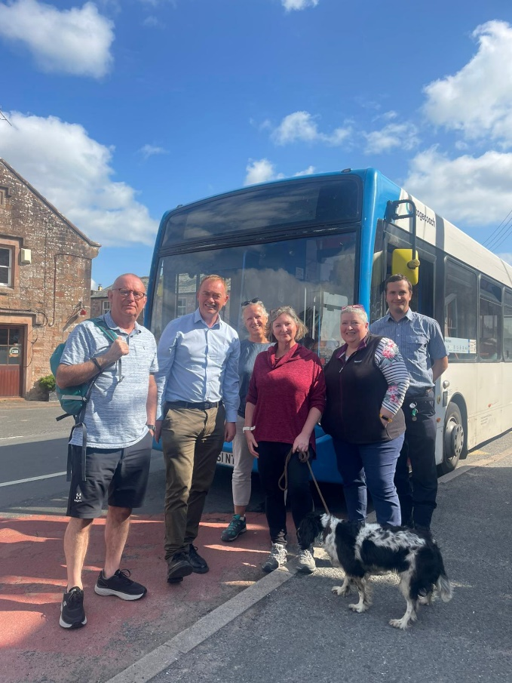

Thank you, Pam Wood

