From: Pam Wood
Sent: 17 August 2025 17:22
To: transport@greystokevillage.co.uk <transport@greystokevillage.co.uk>
Subject: August BUG update

Hello BUGGYs :o) It's been a month of quite busy bus promo when I think about it - a quick round up below:

We did some filming with Westmorland and Furness council that you can view here: Supported bus services open up car free travel this summer | Westmorland and Furness Council Tom was very kind and let us use the castle for a lot of the filming, Sue R did a star turn as interviewee and helped raise the profile of the bus being used to bring people into the village, which all takes a bit of pressure off us having to make the numbers up.

We were on the tellybob again too! A short clip of Greystoke was aired on BBC North West last Thursday; but I think most of us have our TVs tuned to BBC North? I'm trying to work out the best way to show you that as at the moment it's just on my phone. The main theme of that interview was about the comparatively small amount of money per head that the council is given for public transport. Tim Farron has clearly picked up the mantle we put down when we had a video link call with him at the castle and told him about that disparity.

Speaking of Tim, there's a new Herald Article, attached. Tim and Judith, our staunch supporters will be taking a round trip on the 105 this coming Friday 22nd August. They'll leave Penrith at 3pm and come through Greystoke at 15:27. Please do take this opportunity to get aboard and have a chat or ask questions about anything you would like to that you think he might have influence over. He and Judith really do listen and try and help, so don't miss the chance to try and change something for the better.

I have stopped collecting bus tickets now, thank you. As we know, the vast majority of buses run on time, but I definitely need to hear when a bus has been cancelled please. Ideally do that by messaging me directly. I then pass that along to the council. The reason this is useful is that we overlay it with the data stagecoach give us on volume of passengers.

Finally, it warms my heart when I see people using the bus and receive messages about the journeys you take. Please do keep doing that!! My favourite moment yesterday was seeing a queue for the bus, an actual queue!! Including best beloveds Tina and John, plus a child in full disney princess outfit waiting for a bus with her nan. Totally worth every interview this month to see that.

I think that's all for now my dears, warm hugs xx

Pam

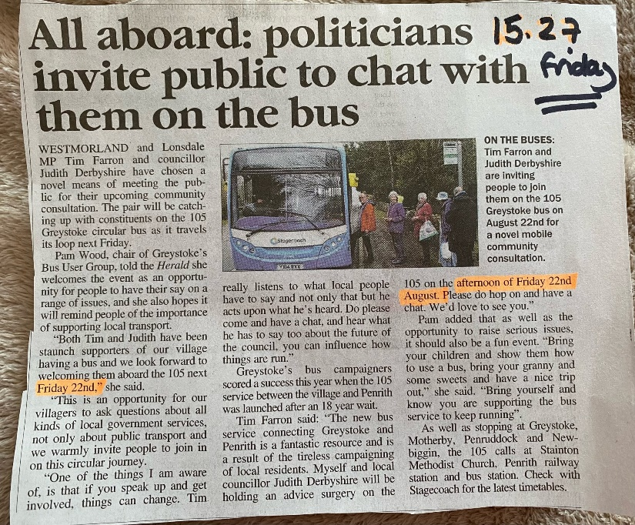

NB, you are receiving this email because you have expressed an interest in the Greystoke Bus User Group. Please message me back if you'd like to be removed from this list.

